**Open Ended Lab**

**LAB # 13**



**Fall 2024**

**CSE-310L Control Systems Lab**

Submitted by:

Registration No.: **21PWCSE**

Class Section: **C**

“On my honor, as student of University of Engineering and Technology, I have neither given nor received unauthorized assistance on this academic work.”

Submitted to:

**Dr. Muniba Ashfaq**

Date:

**12th January 2025**

**Department of Computer Systems Engineering**

**University of Engineering and Technology, Peshawar**

**Task:**

Design negative feedback system both in MATLAB & Simulink and control the step response of given system. Performance requirement of the closed loop system is that the steady state error is zero and overshoot less than 30%.

Given System is:

$$G(s)=\frac{1}{s^{2}+3s+1}$$

**Solution:**

**Code:**

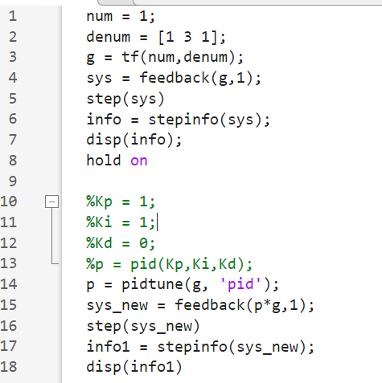

**Output:**

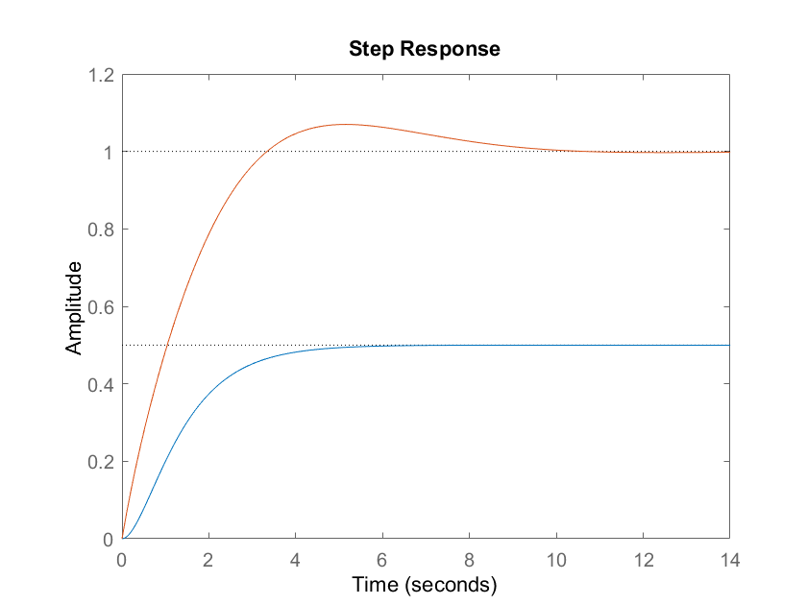

|  |  |  |  |  |  |
| --- | --- | --- | --- | --- | --- |
| Kp | Ki | Kd | Rise time | Overshoot | Settling time |
| 1 | 1 | 1 | 3.12 | 15.18 | 14.68 |
| 2 | 1 | 1 | 2.59 | 4.47 | 8.77 |
| 3 | 1 | 1 | 2.25 | 0 | 3.96 |
| 4 | 1 | 1 | 1.79 | 0 | 6.47 |
| 5 | 1 | 1 | 1.37 | 0 | 8.44 |
| 6 | 1 | 1 | 1.08 | 0 | 9.92 |
| 7 | 1 | 1 | 0.91 | 0 | 11.04 |
| 8 | 1 | 1 | 0.78 | 0 | 11.98 |
| 9 | 1 | 1 | 0.69 | 1.21 | 12.64 |
| 10 | 1 | 1 | 0.63 | 3.07 | 13.37 |

**Simulink:**

